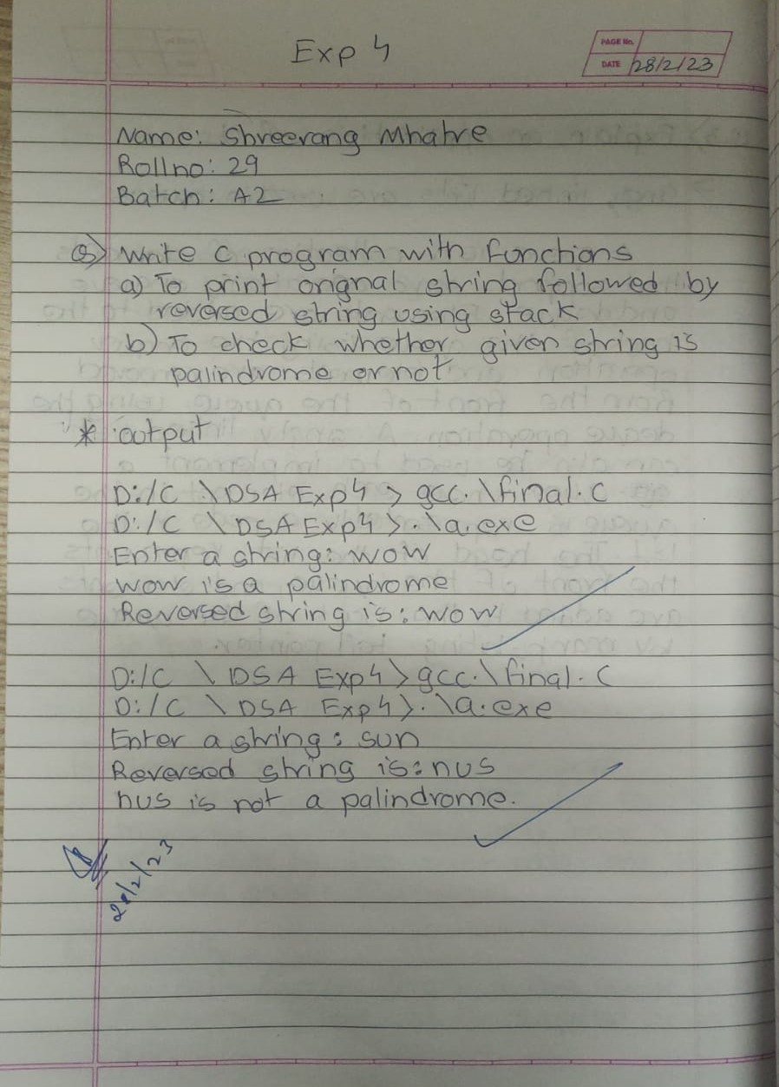

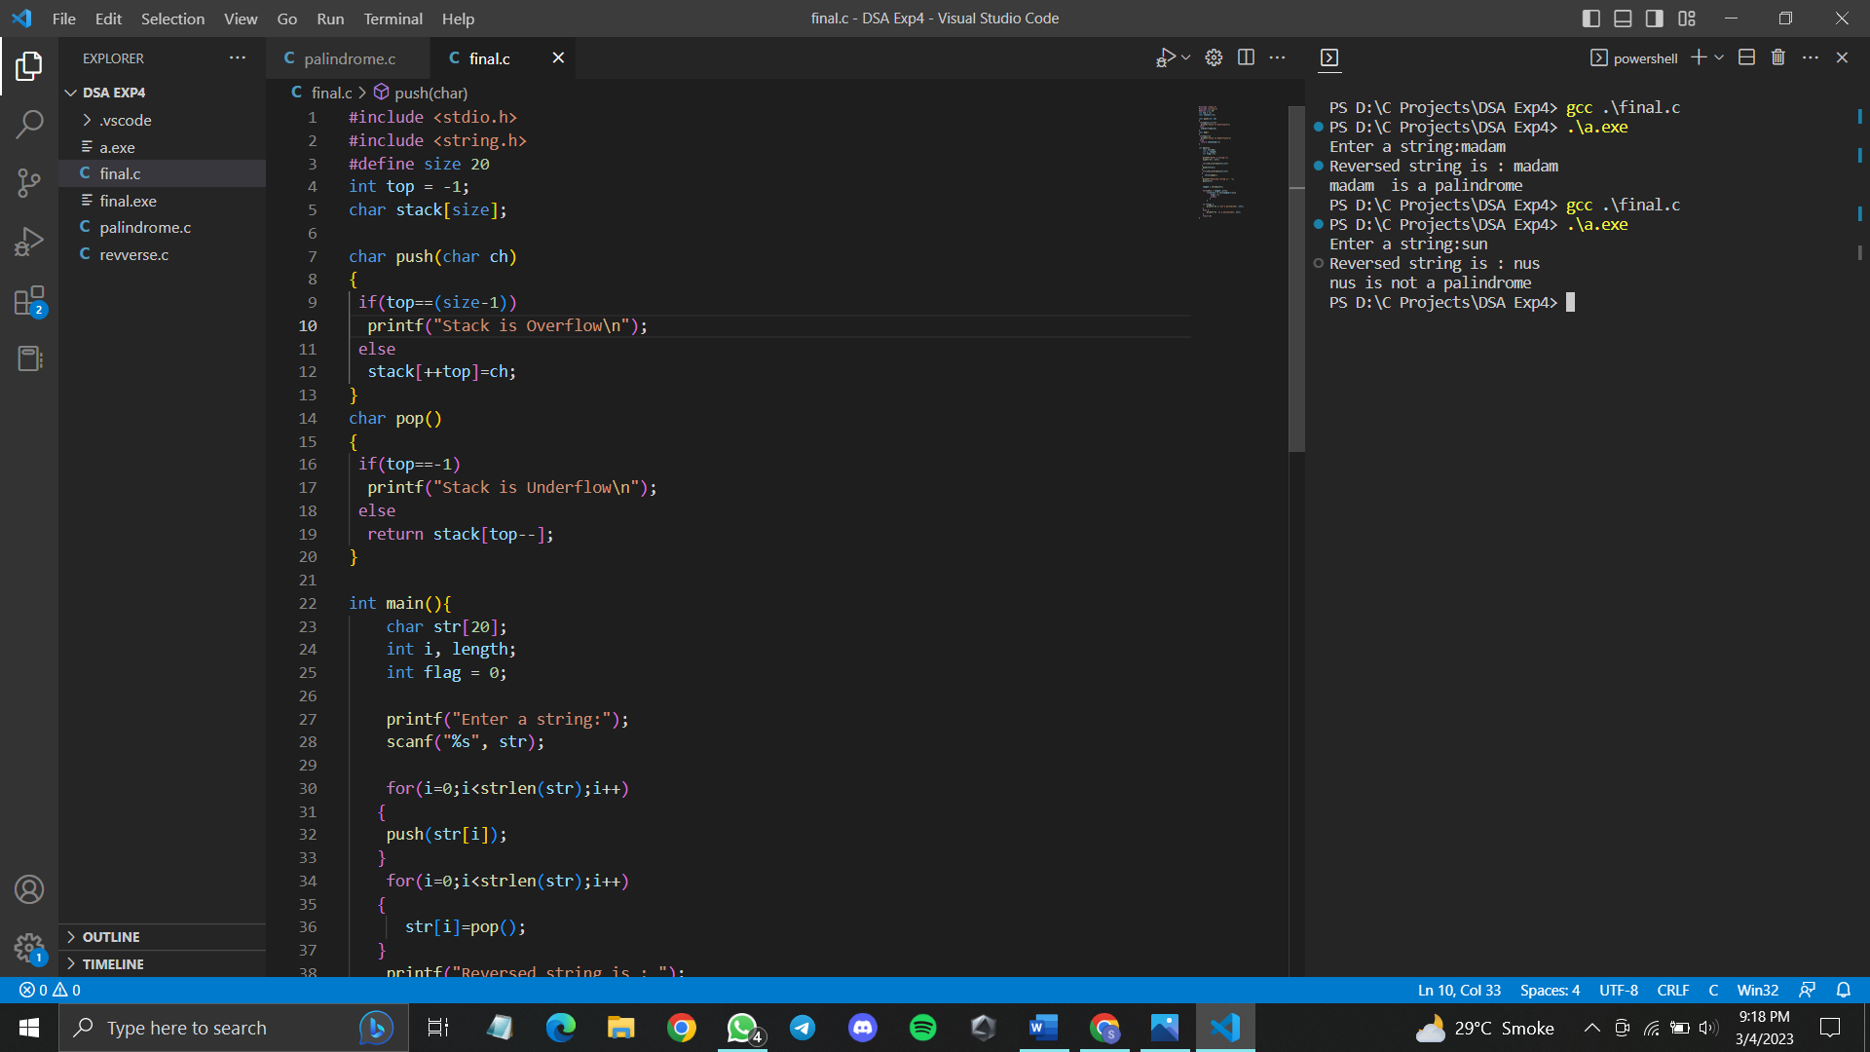

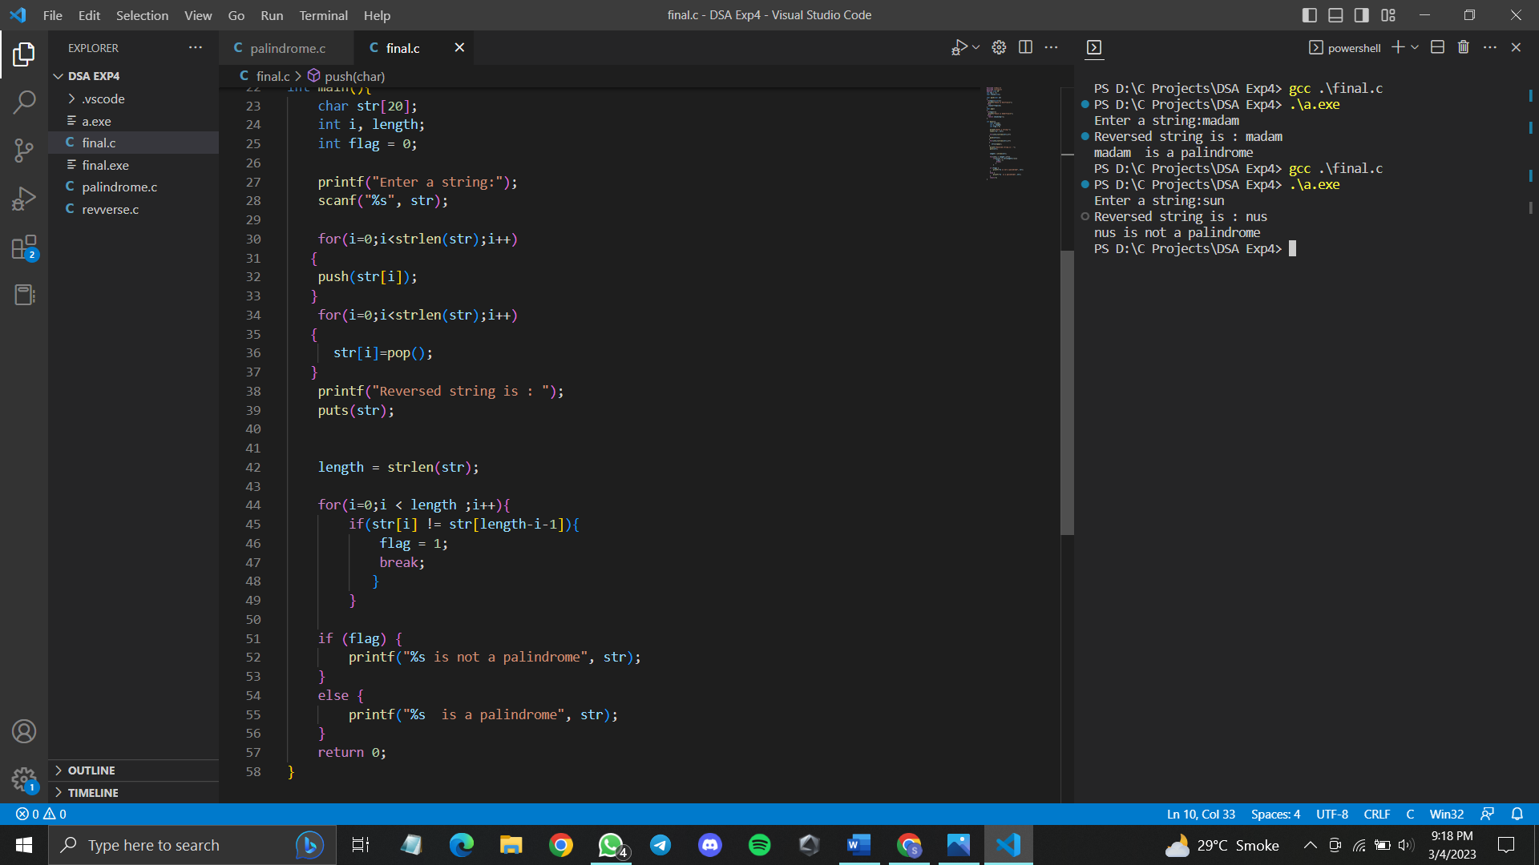

#include <stdio.h>

#include <string.h>

#define size 20

int top = -1;

char stack[size];

char push(char ch)

{

if(top==(size-1))

printf("Stack is Overflow\n");

else

stack[++top]=ch;

}

char pop()

{

if(top==-1)

printf("Stack is Underflow\n");

else

return stack[top--];

}

int main(){

char str[20];

int i, length;

int flag = 0;

printf("Enter a string:");

scanf("%s", str);

for(i=0;i<strlen(str);i++)

{

push(str[i]);

}

for(i=0;i<strlen(str);i++)

{

str[i]=pop();

}

printf("Reversed string is : ");

puts(str);

length = strlen(str);

for(i=0;i < length ;i++){

if(str[i] != str[length-i-1]){

flag = 1;

break;

}

}

if (flag) {

printf("%s is not a palindrome", str);

}

else {

printf("%s is a palindrome", str);

}

return 0;

}

